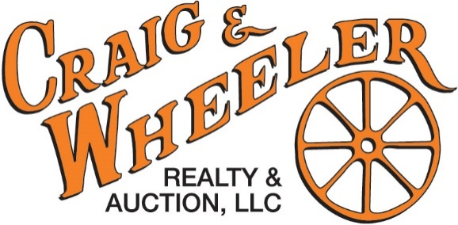
508 South Cannon Blvd. Shelbyville, TN 37160
(931)684-9112
www.craigwheeler.com

BROKER REFERRAL AGREEMENT
REGISTRATION FORM
ATTENTION REALTORS: 1% BROKER REFERRAL REGISTRATION FORM MUST BE FILLED OUT 48 HOURS PRIOR TO AUCTION, NO EXCEPTIONS. 1% OF FINAL BID WILL BE PAID TO AGENT’S FIRM

Referring Agent Name: ___________________________________ Phone: _______________________
Referring Agent Signature:__________________________________ Email: _______________________
Referring Agent’s Company Name: ____________________________________________
Company Address: _________________________________________________________
Bidding Client’s Name: ______________________________ Date:________________________
Bidding Client’s Signature:___________________________ Date:________________________
The above Real Estate Agent hereby wishes to register the above bidder/client as a potential purchaser of the following auction being conducted by Craig & Wheeler Realty & Auction LLC located at:
Auction Address: ______________________________________
Auction Date: _________________________________________
Participating Broker/Realtor will earn 1% of their clients Final Bid Price if the client is the successful bidder and closes as contracted and monies are dispersed. The Broker/Realtor understands that in order to qualify for this commissions, Craig & Wheeler Realty and Auction LLC must receive the registration BY May 20th. The client/bidder understands that he/she may only register with one (1) broker. Only the first broker to register the successful bidder will be paid a commission. There are NO exceptions to these terms and conditions, and NO ORAL registrations will be accepted.
Email the completed form to tcraig@craigwheeler.com

